Name: Sandhiya R
Reg no: 192511132

EXP NO 5: CREATE A SIMPLE CLOUD SOFTWARE APPLICATION FOR LIBRARY BOOK RESERVATION SYSTEM FOR SIMATS LIBRARY USING ANY CLOUD SERVICE PROVIDER TO DEMONSTRATE SAAS
DATE: 08/08/2026
AIM:
To Create a simple cloud software application for Library book reservation system for SIMATS library using any Cloud Service Provider to demonstrate SaaS
PROCEDURE:
PROCEDURE:
step1: Go to zoho.com
step 2: Log into the zoho.com.
step 3: Select one application step.
step4: Enter application name as library book reservation system.
step 5: Created new application as library book reservation system.
step 6: Select one form
step 7: The software has been created.
Output
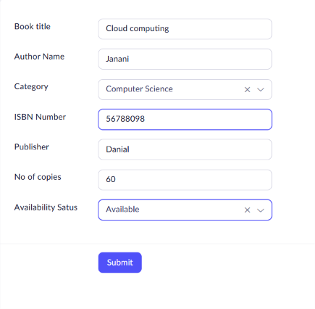
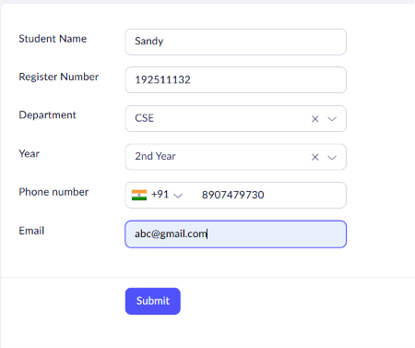
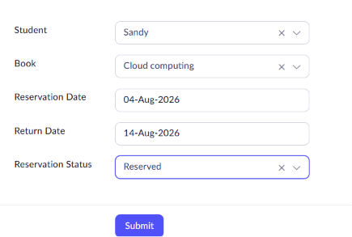
Result
The SIMATS Library Book Reservation System was successfully developed using Zoho Creator. The application enables library staff and students to manage book details, student records, and book reservations through a cloud-based platform.

